Keep the cost down on your wedding by using your creativity rather than your cash. Once you've chosen the theme and colors, shop second hand stores, garage sales, flea markets and dollar stores for decorations and accessories.
Balmy Beach
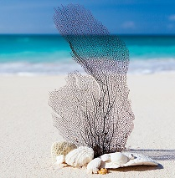
You don't have to be at the beach to have a beach-themed wedding. Think of the colors of the sea -- turquoise, light blue, dark blue, sandy beige and perhaps even a bit of pale pink.
Use palm leaves as a runner down the center of a rectangular shaped table or place one in the center of a round table. Scatter seashells on the leaf and you’re done. Want a little more? Place a few goldfish in glass bowls. The goldfish are cheap as little as 25 cents each. Some pet stores will accept the goldfish back although they won't give you a refund. Or you could give the bowl and fish to guests, much like some brides give the floral centerpieces away as prizes.
Another option is to drape the tables in netting of light, medium and dark blue over white plastic tablecloths. Loop additional netting as a garland around the perimeter of the table.
Baby's breath, or gypsophila, is a light frothy flower that mimics the look of foam on the waves. It will stay fresh without water during your reception. That opens up a number of different ways you can use it. Create a different centerpiece by using a large conch shell nestled in a bed of baby's breath. Surround the conch with scallops or other half shells that cradle a votive candle.
Another alternative is to fill a tall narrow glass vase with the baby's breath inside the vase. Add a bit of sea glass to the bottom of the vase before filling and scatter more sea glass on the table. Sand dollars serve as place markers with the guests' names on each. Spray paint shells in metallic colors for a glamourous look.
Put a photograph of the bridal couple inside a glass bottle, a single serving size wine bottle is the perfect size. Add a few shells and sand to the bottle. You've got a memento for your guests. Another favor is inexpensive beach towels rolled up and tied with twine or raffia.
Decorate the cake with seashells made of frosting or find seashell-shaped candy decorate the cake with the candy.
Incorporate starfish or seashells into your and your wedding attendants' bouquets and boutonnieres, and corsages. Hot glue onto sturdy wire stems. Have each attendant carry a paper parasol instead of or in addition to a bouquet. Choose flowers that are reminiscent of coral or sea creatures such as protea.
Of course seafood is the perfect menu for a beach-themed wedding. Serve shrimp wrapped in bacon, fish tacos, or seafood salads served in single serving plastic cups. Chicken of course is an option for those who just can't tolerate fish.
Fruit Fantasy
Choose your favorite fruit as the theme. For example, let’s say you love citrus fruits. Your color scheme falls right into place with lemon yellow, pink grapefruit, luscious limes and the pop of orange.
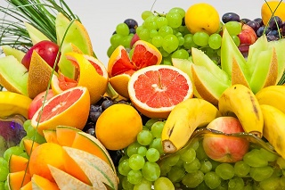
Centerpiece is simply a bowl or basket of fruit. Use a glass bowl so the colors shine through. Fill the basket with paper towels and a layer of raffia so the fruits sit above the rim. That way you won't waste fruit in the bottom of the basket where it can't be seen. Another alternative are wreaths made from dried fruit slices and hot glued to a grapevine wreath.
For the cake table, gift table and the head table consider professionally made bouquets of fruit cut and assembled to look like flowers. They aren't that much more expensive than centerpieces from a florist.
Dry the fruit yourself in a dehydrator to save major money. Pink and red grapefruit and oranges dry beautifully. However, limes and lemons turn brownish. Create centerpieces of fresh citrus slices on wooden skewers. Fill in with greenery and perhaps small flowers such as mini carnations in citrus colors.
Add small fruits such as tiny orange kumquats, key limes and small lemons to your bouquet. Push a sturdy wire through the fruit right before attaching to the bouquet. Keep the bouquets in citrus colors. Try a different color for each of your attendant's bouquets. Another option is to use realistic artificial fruits in the bouquets. Integrate real fruit such as strawberries, grape clusters, pomegranates in the floral center pieces.
Offer each guest a fruit filled mini basket as a favor or find small wooden boxes at your craft store. Add your names and wedding date to the basket. This of course works best with smaller fruits. Another option is to fill small white gift bags with fruit.
Instead of a candy table offer a fruit bar. Or choose candy in fruit shapes and flavors. Serve fruit salad in hollowed out grapefruit halves. Lemon halves make perfect sorbet cups. Orange halves could hold a vegetable seasoned with orange juice. The entrée could be citrus chicken or pork with peaches.
Decorate the cake with premade marzipan fruits. Another alternative is to use sugared fruit slices. Cut the fruits. Dip fruits in diluted lemon juice and then into sugar. The sugar adds a sparkle to the fruit. Dip orange slices half in chocolate and use those as the decoration. Strawberries dipped in white chocolate and drizzled with dark chocolate are another option.

Country Garden
If you're having an outdoor reception a country garden theme fits right in. Start collecting lace tablecloths or purchase lace by the yard. Layer over colored paper table clothes. Another alternative is to use inexpensive fabric in floral prints as the table clothes.
Spray paint old fashioned watering cans in your wedding colors. It doesn't matter if the cans have holes in them. Place bouquets of baby's breath in the cans. The baby's breath stays fresh for hours without water. Or you could tie bunches of helium balloons to the cans.
Bird houses work as sweet centerpieces. Find them at craft stores.
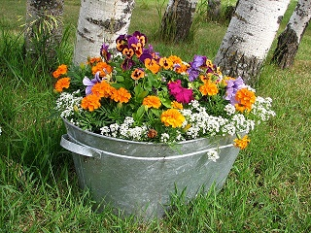
Give your guests a fragrant favor. Find doll-sized straw hats at the craft store. Fill the hat with potpourri then hot glue fabric to the hat to keep the potpourri inside. Add a few silk flowers to decorate the brim. Another alternative is to buy a few bunches of small sized flowers and press them dry so they're flat. Glue the dried flowers with white glue around the base of a pillar candle. Brush with modgepodge or dip the candle in melted was to seal.

Flowers, flowers, and more flowers are the theme of the hour. Instead of cut flowers, consider getting flats of flowers from the nursery or big box store and replanting in containers you can use in your new home. Plastic flower pots are light weight and take to spray paint for an extra pop of color. Plant the pots about two to three weeks before the wedding so the plants have a chance to fill out. If you don't want to use the plants in your own garden, give them to a senior center or assisted living facility.
Consider a boxed lunch as the meal rather than a sit down lunch or buffet. Fill white take out boxes with fried chicken, single serving containers of salad, eating utensils and a piece of fruit. Tie the boxes with ribbons in your wedding colors.
Decorate your cake with fresh edible flowers available online. You could also order from the grocery store. Do not use flowers from your garden unless it's pesticide and herbicide free. Flowers are difficult to rinse and any lingering pesticide could be a problem.
Another option is to use a basket weave icing design for the cake and place a bouquet of edible roses on the top. Consider a "cake" made of cupcakes each topped with large icing flower.
Western Flair
Get your cowboy boots on and get ready to party. A western theme is informal and invites you to have fun. Visit second hand clothing and thrift shops for cowboy boots. Rinse out with a solution of one cup bleach to one quart of water. Scrub off the outside with soapy water. Rinse and then stuff with rolled up newspaper to keep their upright shape while they dry. Once dry spray paint in your wedding colors or bright reds, oranges and navy blues. Fill with bunches of dried flowers and your centerpieces are done. If you want to use fresh flowers place a jar or glass inside the boot to hold the flowers and water.
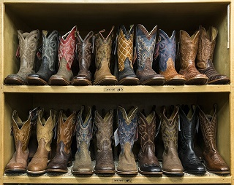
If that's too much work for you, use a single cactus in a pot as the center piece. Wrap the container with a bandana and repeat the theme by using the bandanas as napkins. Roll up and tie with raffia. Cheap bandanas can be found at dollar stores, online and craft stores.
Stich or staple the bandanas together to form a table runner.
Don't want to use cactus? Fine, then use a straw cowboy hat. Fit it with a watertight container filled with floral foam. Add wild flowers in a random fashion so the hats look like they were plucked straight from the garden. Another option are old fashioned coffee pots filled with flowers.
Denim jackets or shirts over your formal wedding dress and bridemaid's dresses for you and your bridesmaids add a classic western touch.
Keep the western theme going with a cowboy menu, you'll save money too. Start with chili soup served with mini corn muffins. You might think steak for the entrée but then you run into the problem of who gets rare and who wants well done. Instead serve barbecue slow-cooked beef or pork. Add biscuits, coleslaw, macaroni and potato salads. Throw in some corn on the cob and your menu is ready. This type of dinner saves money on catering as well. You could buy this entire menu at the grocery store for even more savings.
For an early afternoon wedding consider a cowboy brunch of scrambled eggs, ham slices, hash browns, red eye gravy, biscuits and blueberry muffins, served with mimosas - orange juice and champagne. Almost all of this menu can be made ahead and reheated.
Straw bales add to the ambiance. Scatter a few around as extra seating.

Perfectly Patriotic
Weddings taking place around Memorial Day, Fourth of July or Labor Day can take advantage of a patriotic theme. Select red or blue bridesmaid dresses and accent each with a sash of stars and stripes. Carry a bouquet of red, white and blue. Add a tiny American flag to corsages and boutonnieres.
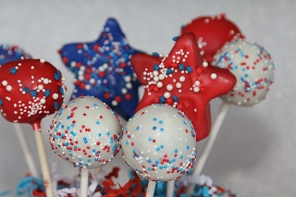
Use blue vases filled with red carnations and white baby's breath. Blue flowers are difficult to find. So consider silk blue flowers instead of fresh. Spray paint mason quart jars blue if you can't find enough blue vases. Another idea is small flags from 12 to 18 inches long stuck into foam covered with moss. Or wrap the bottom third of white pillar candles with red and blue ribbon. Surround with red, white and blue votive candles in clear holders.

Fill clear glass vases with layers of red, white, and blue hard candy. Or stick cake pops decorated with red, white, and blue sprinkles in floral foam covered with shredded red foil.
Make your centerpieces to double duty as guest favors. Write your name, his name and the date on the wings of a pinwheel for guests to take home. Place as many pinwheels in a mason jar as guests at the table. For example a table that seats six would have six pinwheels.
Fill cellophane bags with jelly beans in red, white and blue for your guests. Tie with striped ribbons. Another favor would be small soaps in the same colors. Just make sure your guests know it's soap and not candy.
Fourth of July wouldn't be the Fourth without hamburgers and hot dogs. Either go classic or upscale. Offer a condiment bar with shredded cheeses, pickles, onions, sweet relish, sliced jalapenos, sriracha and barbecue sauce, ketchup, mustard and mayo, corn chips, sliced tomatoes shredded lettuce, sauerkraut, guacamole, olives and whatever else you think would work.
Upscale burgers include tiny beef sliders topped with bleu cheese and crispy onions, salmon sliders topped with sour cream, dill and lemon zest and chicken tenders with a tarragon enhanced hollandaise sauce. Arrange a platter of red and white vegetables served with bleu cheese dip. Place red raspberries, blueberries and strawberries in white snow cone wrappers.
Your wedding cake could be decorated in stars and stripes icing. Another option is use red raspberries and blueberries to create designs on the cake. These have to be added at the last minute as the juice from the berries will discolor the white frosting.

