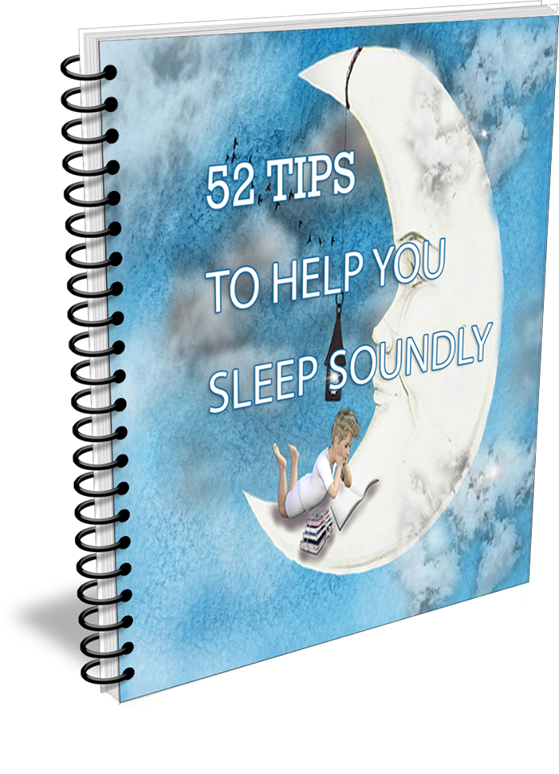
52 Tips and Tricks to Help You Fall Asleep Fast and Stay Asleep
Sleepless in Seattle? Awake in Anchorage? Restless in Rhode Island? Try these easy sleep tips.
Introduction
You might think that missing a few hours of sleep every night really doesn't matter in the long run. After all lots of people get along with five or six hours of sleep right? Wrong. Lack of sleep has very serious consequences. Eventually sleep deprivation catches up with you.
Nearly everyone has had trouble falling asleep and staying asleep. It's a common problem affecting all ages from children to grandparents. You go to sleep at a reasonable hour but toss and turn. Or you wake up over and over again.
It's critical to get a good night's sleep, but sometimes it's a struggle. Addictive sleeping pills aren't the answer. You want to wake up refreshed not groggy.
Lack of sleep leads to serious health problems such as:
Heart disease
Heart attacks
Heart failure
Irregular heart beat
High blood pressure
Stroke and diabetes
Not only does not enough sleep have life threatening consequences it affects day-to-day functioning.
The Center for Disease Control and Preventions says lack of sleep is linked to accidents, on the job mistakes, impaired energy, fatigue, and emotional and mental instability.
90% of those suffering from depression also suffer from insomnia as well
100,000 auto crashes per year are a consequence of fatigue resulting in 1550 crash related deaths.

Lack of Sleep Impairs:

Attention: Lack of sleep shortens your attention span. You become easily distracted.
Alertness: When you're tired your brain misses cues that lead to recognizing warning signs. It could be as simple as forgetting where you put your keys last night or more dangerous as when you forget to lock the front door.
Concentration: When you're tired it's difficult to focus on the task at hand, whether it's physical hand and eye coordination, reading and processing what you've read, or day-to-day chores.
Reasoning and Problem solving: Studies have shown that sleep deprivation causes slower thought processes. Just a single bad night's sleep results in slower problem solving.
Deep sleep cycles consolidate memories of the previous day. Miss those sleep cycles and your memory falters.

Sleep Deprivation Affects Your Daily Life
It kills your sex drive. This is especially a problem when one partner gets enough sleep and is raring to go and the other is sleep deprived and only wants a good night's sleep. New mothers often have this problem since they're up with the baby every few hours.
Ages your skin. You've probably noticed that your skin looks drawn and haggard after you've had a bad night's sleep. That goes away if you usually sleep well. It becomes more permanent if you consistently lose sleep.
Causes your body to release more cortisol and less human growth hormones. The cortisol causes weight gain.
Causes you to gain weight. People who sleep less than 7 hour a night have a tendency to gain weight more than those who get a full night's sleep.
Increases hunger and appetite. When you're tired you compensate for lack of sleep by eating. You don't have time for a 30 minute nap while you're at work for example, so you hit the vending machines instead.
Stimulates cravings for high-fat, high carbohydrate foods. Not only do you compensates for lack of sleep by eating but by eating foods that aren't good for you such as foods high in fat and carbohydrates.
Lack of sleep leads to depression which worsens insomnia in a vicious cycle.
Your body repairs itself while you're asleep. Sleep is the first defense against common illnesses, such as the cold or flu. Your immune system goes full throttle while you’re asleep.
So What Can You Do?
Okay so now you know how important it is to get at least seven hours of restful sleep per night. Knowing you need the sleep is easy, getting a sound night's sleep is a challenge. In fact worrying about not getting enough sleep is one of the causes of not sleeping well.
These 52 Tips were developed to help you fall asleep fast and stay asleep. Not every tip works for every person. However, you'll find quite a few of the tips work for you.
So here we go

52 Tips and Tricks to Help You Fall Asleep Fast and Stay Asleep
1. Put your muscles to work putting you to sleep. Sounds counter intuitive but it works. As you lie in bed, tense each of your muscle groups for 15 to 20 seconds then relax. Start with your feet, move up to your calves, knees, and thighs. Then tense your abdomen, buttocks and finally move to your upper body and arms. By the time you reach your forehead muscles you’ll be ready to nod off.
2. Focusing on falling asleep is counterproductive. Instead think of a recent pleasant experience, a movie you’ve enjoyed, a happy memory, or a relaxing vacation moment. Replay the movie or the plot of the novel in your mind. You’ll be asleep before the movie ends.
3, Take a hot bath or shower. Your body temperature drops when it’s time to sleep. Mimic that temperature drop when you come out of a nice hot shower. Don’t wrap up in a warm bathrobe right away.
4. Your childhood games can put you to sleep. Remember the alphabet game A is for apple, B is for bear and so forth? The mindlessness of the game takes your focus off day-to-day worries and lets your mind relax. You’ll be asleep before you hit the middle of the alphabet.
5. Come up with a mantra, a saying, or statement. When your mind starts to wander and keeps you awake say the mantra over and over. It’s sort of like meditation. Here’s an example “Roses are Red. Violets are blue. I’ll be asleep in a moment or two.”
6. Lavender floats you off to dreamland. Place a few drops of lavender essential oil on a cotton ball, then put on your nightstand. Take a warm bath, adding a cup of Epsom salts and a few drops of lavender essential oil.
7. You know about lavender essential oil but did you know that other essential oils work as well? Jasmine calms the nervous system. Studies have shown it’s as effective as sedatives without that morning after grogginess. Put four drops of jasmine oil on a cotton ball then tuck under your pillow.
8. Keep a sachet of lavender, jasmine, or rose essential oils in the same drawer with your pajamas or nightgown. Just opening the door relaxes you. And who doesn’t want to smell lovely as they drift off to dreamland.
9. Say yes to Yoga. The stretching, relaxation and focus helps you sleep. Watch an online video for the basic positions. Keep in mind that as a novice you’re not expected to execute each pose perfectly. Do the best you can. Ballet stretches and gentle Pilates works as well.
10. Use your high school geography lessons to fall asleep. Name the states in alphabetical order. This is another exercise that focuses your mind away from your troubles.
11. Massage soothes away tension and relaxes muscles so you float off to sleep. Try rolling a tennis ball with your feet, use a hand-held massager for your lower back or roll your back on a foam tube used to float in a swimming pool. Consider investing in a self- massager. The equipment looks awkward at first but once you learn how, it’s easy.
12. Speaking of swimming pools. Think of yourself gently floating in a warm swimming pool. Close your eyes and feel the gentle waves rock you to sleep.
13. Passion flower extract works as well as valium in reducing stress and inducing relaxation. It also cuts your risk of middle of the night wakefulness. Try 350 to 700 mg right before bed. Combine the passion flower extract with a warm cup of chamomile tea.
14. It's not just an old wives' tale, warm milk and honey or hot cocoa acts as a mild sedative.
15. No caffeine after noon, that means sodas and teas as well as coffee. Check your labels. Some individuals are very sensitive to caffeine. Others could drink a pot of coffee 15 minutes before bed and be just fine. Energy drinks are loaded with caffeine that’s where the energy boost comes from.
16. Maintain a regular sleep schedule. If you miss sleep one night, don't try to make up for it with naps or sleeping in the next day. That just prolongs the problem because you won't be tired by your regular bedtime, which means you won’t fall asleep quickly resulting in being even more tired the next day.
17. Establish a bedtime routine. For example, take a warm bath, drink a cup of tea and read for 30 minutes before you get into bed. The ritual you choose signals your brain it's time to sleep. What you do isn't necessarily important, it's that you do the same thing every evening.
18. Chamomile tea relaxes you. It's often the main ingredient in "sleepy time tea." If you awaken in the middle of the night, consider stashing a thermos of chamomile tea by your bed to sip. Cold tea works but the warmth of hot tea is soothing.
19. Keep a sleep journal. Note any unusual events during the day and how you slept that night. You may see a pattern emerge. Perhaps you have trouble sleeping Sunday nights because you're worried about work on Monday. Or maybe you sleep badly after talking with certain friends or relatives.
20. Procrastinators are up to three times as likely to have insomnia. You may not be able to get everything done on your to do list so you worry. Instead focus on accomplishing one task then when you start worrying about what you didn’t accomplish remember what you did get done.
21. Hang up your worries. As you’re lying in bed you might start to worry. If you do, visualize yourself hanging up the worry in a closet. You’ll most likely drift off before the closet is full.
22. Give yourself 20 minutes to fall asleep. If it hasn’t happened then get up and read or listen to soft music until you feel sleepy again. Tossing and turning just leads to aggravation.
23. Rose essential oil to the rescue. A drop of rose oil on your forearm or wrist decreases your adrenaline level. An added bonus is you’ll smell heavenly. Before putting any oil on your skin, dilute it with a bland carrier oil such as coconut oil. Place four or five drops of essential oil into a tablespoon of carrier oil. Put the diluted oil on your skin. After 24 hours any symptoms of a allergic reaction should show up. If there aren’t any, it’s safe to use the undiluted essential oil.
24. Turn off the lights – all the lights. Put your cell phone in the nightstand drawer. Turn the clock so you aren’t bothered by the lighted numbers. If you must have a night light, use one that is motion sensitive.
25. Your bedroom is for sleeping. Keep any reminders of work in another room, which means any handheld devices, your computer, and brief case.
26. If turning out the lights isn’t an option or you must sleep during the day, invest in a good quality eye mask.
27. White noise is effective in blocking out distractive noises. If you don’t want a bulky machine use padded sleep headphones. They’re super comfortable and do a better job than a freestanding machine.
28. Get a splash of sunlight every day. As little as 10 minutes helps you sleep better at night. If you don’t use a sunscreen that 10 minutes amps up your body’s production of vitamin D.
29. Take a walk in the forest, in a park or even in your own garden for 15 minutes every day. A study shows that woman who did that enjoyed deeper sleep than those who walked in a mall, city streets or on a treadmill.
30. Count sheep. Seriously, picture sheep jumping over a fence. It works because you’re focusing on a repetitive image that’s boring.
31. And while you’re counting try the 4-7-8 trick developed by Dr. Andrew Weill. Inhale for 4 seconds. Hold your breath for seven seconds then gently exhale for 8 seconds. Repeat as necessary but it won’t take long.
32. Lift up your arms. No, not in frustration because you can’t sleep, but to build up your arm strength. Grab a light weight, a soup can will do, and lift the cans over your head for three sets of 12 repetitions. Do the same for bicep curls and rows. Studies show doing this three times a week reduces anxiety, improves your mood and gets rid of stress. That means you sleep better.
33. Is your pillow comfortable? A saggy lumpy pillow won’t do anything to help you get a good night’s sleep. It should be fresh smelling as well. People who sleep on their side get the best quality night’s sleep. It may be helpful to use a full body pillow you hug while on your side. Experts say if you sleep on your back that you shouldn’t use any pillow at all, since it torques your neck.
34. Cool it – the bedroom temperature that is. Most people sleep the best when the room is between 60 to 75 degrees.
35. One hour before bed stop texting, playing video games or watching action packed movies or TV. Overdoing mental stimulation right before bed makes it more difficult to fall asleep.
36. Go easy on the alcohol. Yes, it’s a sedative but when that effect wears off in three or four hours you wake up. Enjoy your libations before 7 pm.
37. Give your green thumb a go and place lots of live plants in your bedroom. The plants remove toxins in the air and add oxygen.
38. Turn your clock’s face away from you. Do not look at it if you wake up. You don’t need to start worrying that you only have an hour more to sleep before you have to get up or that you’ve already been awake for two hours straight.
39.. Force yourself to stay awake. It’s called the sleep paradox. Force your eyes to stay open in the dark room. Repeat I will not fall asleep, over and over. The brain doesn’t process negatives very well. So it will take that as a command to fall asleep. 40. Additionally after a long day your eye muscles are already tired, so keeping them open is hard work.
41. Say thank you. Before you go to bed at night think of what you’re grateful for. A study in Arizona showed those who were grateful slept more soundly.
42. Weigh yourself down with a weighted blanket. It works on the same principle that swaddling a baby helps calm it down. Think of the blanket as giving you a full body hug.
43. Sleep supplements include melatonin but did you know that L-ornithine, an amino acid, curbs stress and triggers relaxation. A 400 mg dosage does the trick.
44. Pressure points work similarly to acupuncture but without the needles. Press your index fingers in the spot on your forehead between your eyebrows that has a slight indentation. Hold for 20 seconds, release and then press again. Pressing in the indentation between your big and second toe works too.
45. Snore no more and stay asleep. It sounds silly but flexing your feet during the day reduces snoring. Sitting during the day causes fluid to build up in your lower legs. When you lie down to sleep that fluid travels and puts pressure on your airways. Flex your feet – place your feet flat and then raise your heel up while keeping your toes on the ground, then lift your toes and balls of your feet while your heels remain on the ground. Walking around at least once every hour helps reduce fluid buildup as well.
46. While exercising during the day is great don’t exercise in the evening, if you can help it. Exercise revs up your energy level which is exactly what you don’t want.
47. There’s a reason babies fall asleep while being rocked. Rock yourself in a comfy rocking chair while listening to soothing music.
48. Destress before bedtime with a steamy shower scented with eucalyptus and tea tree essential oils. Place one cup of sea salt into an 8 oz. container. Fill almost to the brim with a carrier oil such as almond or avocado. Add 20 drops each eucalyptus and tea tree oil. At shower time use a handful to scrub away stress (slough off dead skin as well).
49. Imagine your troubles floating down a river one by one.
50. Get rid of “reverberating” noise, that’s noise that echoes off of hard surfaces such as floors and walls. Carpet the floors or use throw rugs. Hang draperies over the windows. Place pictures on the wall. These absorb sounds to quiet your bedroom.
51. Sing yourself a lullaby or at least go over the words in hour mind as you drift on to sleep.
52. Have a bedtime snack of sleep inducing foods such as cheese and crackers, a slice of turkey, or a cup of tomato soup.

